GRAPHS

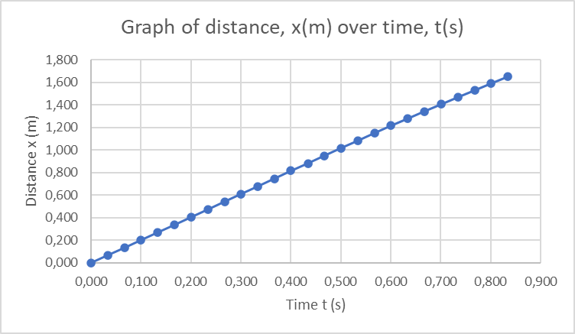

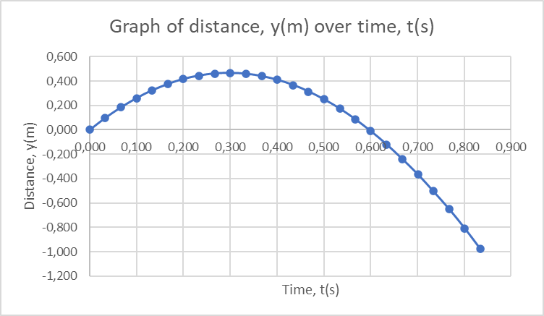

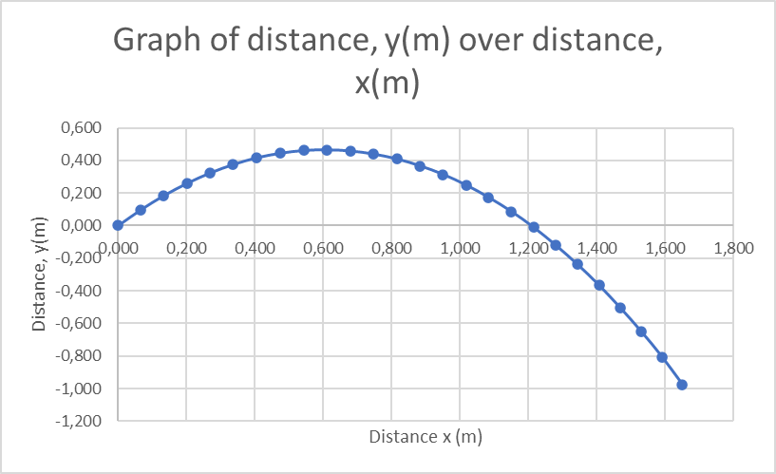

[B2] Comment on the shape of the graphs and to what extent they agree or disagree with the theory.
Hint: Fit a quadratic curve to the graph of y(t) and compare its coefficients with the expected experimental values. (Google graphs can do it. Go to “Chart Style”->”Series” and select “Trend Line”. There you can select a quadratic graph and there is an option to print the equation.

The x(t) graph is in a linear shape which means that distance is continuous as time goes by, thus agreeing with the projectile motion theory. The y(t) graph is in the shape of a parabola which shows that gravitational acceleration (9.8m/s2) is involved, also an aspect of the projectile motion theory. The y(x) graph is also in the shape of a parabola that shows that downward acceleration is present, and also agrees to the projectile motion theory.

Calculating vx(t) and vy(t) and ay,avg,(t)
(If using a computer, plot all points, if plotting by hand, use the same points as previously.)

[B3] Calculate v_{x,avg},(t) = x/ t and v_{y,avg},(t) = y/ t for every time interval and present your results in a table. Note that the best time to associate with the average velocity is the midpoint of the interval. So, if you use the interval from t = 0.4 to t = 0.5 s, then the calculated average velocity corresponds best with the instantaneous velocity at t = 0.45 s.

[B4] Using the results obtained in the previous section, calculate a_{y,avg},(t) = v_{y,avg} / t, present your results in a table. Note that the best time to associate with the average acceleration is the midpoint of the intervals used in B3 above.

The table is on the next page. Remember to label the column headings using the correct format, with symbols and units.

[B4] Plot graphs of v_{x}(t) and v_{y}(t) and a_{y}(t). Also calculate the average acceleration of the ball during its flight. (Remember rules for drawing graphs!)

[B5] Comment on the shape of the graphs and to what extent they agree or disagree with the theory.
The graph of v_{x}(t) is scattered widely but has a parabolic trendline which suggests that the average velocity decreases over the midpoint intervals of time due to air resistance. This therefore agrees with the theory of projectile motion.
The v_{y}(t) graph is in the shape of a linear line which suggests that the average velocity decreases as time goes by, thus agreeing with the theory of projectile motion.
The shape of the a_{y}(t) graph is scattered with a trendline that is linear and has a small gradient, that suggests that there is a constant average acceleration at some point. This agrees with the projectile motion theory.

TABLE 2

Title: Table plotting Time t(s), Horizontal distance x(m), Vertical distance y(m), Midpoint of time intervals: mid t1(s); mid t2(s), Average velocity V_{x}(m/s), Average velocity V_{y}(m/s), Average acceleration A_{y}(m/s2) of the projectile motion of a ball.

t (s) | x (m) | y (m) | Midpoint of time interval  mid t1(s) | Average velocity  V_{x}(m/s) | Average velocity  V_{y}(m/s) |  | Midpoint of time interval  mid t2(s) | Average acceleration  A_{y}(m/s2)
0.000 | 0.000 | 0.000 | 0,017 | 2,030 | 2,970 |  | 0,033 | -12,265
0.033 | 0.067 | 0.098 | 0,050 | 1,971 | 2,559 |  | 0,067 | -8,604
0.067 | 0.134 | 0.185 | 0,084 | 2,061 | 2,273 |  | 0,100 | -10,936
0.100 | 0.202 | 0.260 | 0,117 | 2,030 | 1,909 |  | 0,133 | -11,334
0.133 | 0.269 | 0.323 | 0,150 | 2,000 | 1,529 |  | 0,167 | -8,567
0.167 | 0.337 | 0.375 | 0,184 | 2,061 | 1,242 |  | 0,200 | -12,504
0.200 | 0.405 | 0.416 | 0,217 | 2,029 | 0,824 |  | 0,234 | -9,275
0.234 | 0.474 | 0.444 | 0,251 | 2,091 | 0,515 |  | 0,267 | -11,848
0.267 | 0.543 | 0.461 | 0,284 | 2,061 | 0,121 |  | 0,300 | -9,764
0.300 | 0.611 | 0.465 | 0,317 | 2,000 | -0,206 |  | 0,334 | -11,124
0.334 | 0.679 | 0.458 | 0,351 | 2,091 | -0,576 |  | 0,367 | -10,025
0.367 | 0.748 | 0.439 | 0,384 | 2,061 | -0,909 |  | 0,400 | -9,737
0.400 | 0.816 | 0.409 | 0,417 | 1,971 | -1,235 |  | 0,434 | -11,151
0.434 | 0.883 | 0.367 | 0,451 | 2,061 | -1,606 |  | 0,467 | -10,936
0.467 | 0.951 | 0.314 | 0,484 | 2,030 | -1,970 |  | 0,500 | -7,928
0.500 | 1.018 | 0.249 | 0,517 | 1,941 | -2,235 |  | 0,534 | -12,062
0.534 | 1.084 | 0.173 | 0,551 | 2,030 | -2,636 |  | 0,567 | -9,114
0.567 | 1.151 | 0.086 | 0,584 | 1,970 | -2,939 |  | 0,600 | -7,955
0.600 | 1.216 | -0.011 | 0,617 | 1,882 | -3,206 |  | 0,634 | -11,041
0.634 | 1.280 | -0.120 | 0,651 | 1,939 | -3,576 |  | 0,667 | -5,640
0.667 | 1.344 | -0.238 | 0,684 | 1,853 | -3,765 |  | 0,701 | -12,451
0.701 | 1.407 | -0.366 | 0,718 | 1,879 | -4,182 |  | 0,734 | -4,230
0.734 | 1.469 | -0.504 | 0,751 | 1,824 | -4,324 |  | 0,768 | -12,143
0.768 | 1.531 | -0.651 | 0,785 | 1,848 | -4,727 |  | 0,801 | 1,814
0.801 | 1.592 | -0.807 | 0,818 | 1,788 | -5,061 |  | 0,617 | -9,524
0.834 | 1.651 | -0.974 | 0,417 | 1,980 | -1,168 |  | 0,209 | -5,601

Average acceleration = -9,383 m/s2

GRAPHS

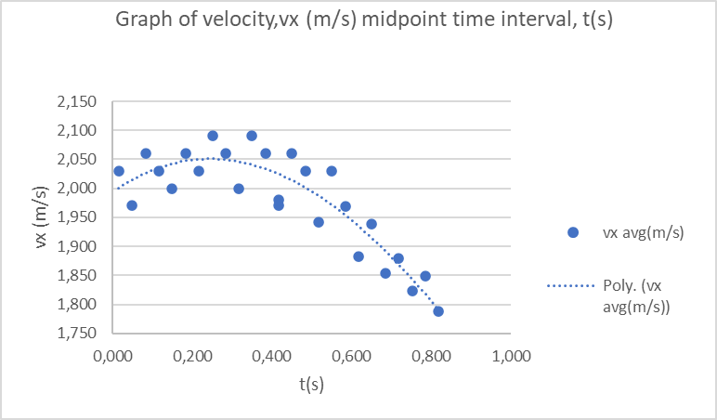

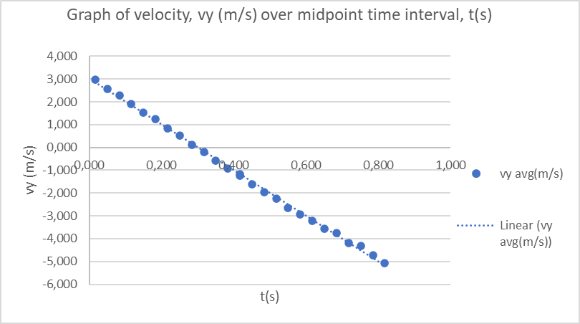

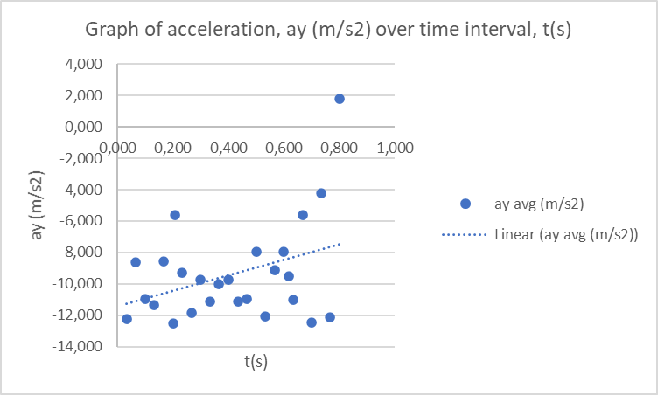

[C7] Comment on your answer in [C6] and how well it corresponds to theory.
The magnitude that is calculated is this experiment is close to gravitational acceleration (9.8m/s).
This is proof that the results are measured and calculated very accurately. The acceleration v_{y}, is almost completely vertical because of the forces like gravitational force and air resistance being vertical forces.

PART D: Discussion:

Are the results obtained in this experiment 100% accurate? List the aspects that you think could contribute to answers deviating from the ideal.
No the results obtained in this experiment are not 100% accurate and this could be due to air resistance, timing errors and human errors

GRAPH PAPER

